Major Difference between Discrete and Continuous Random variable

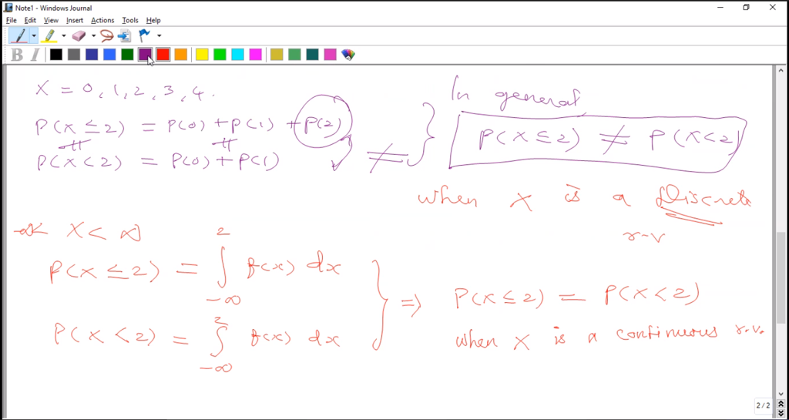

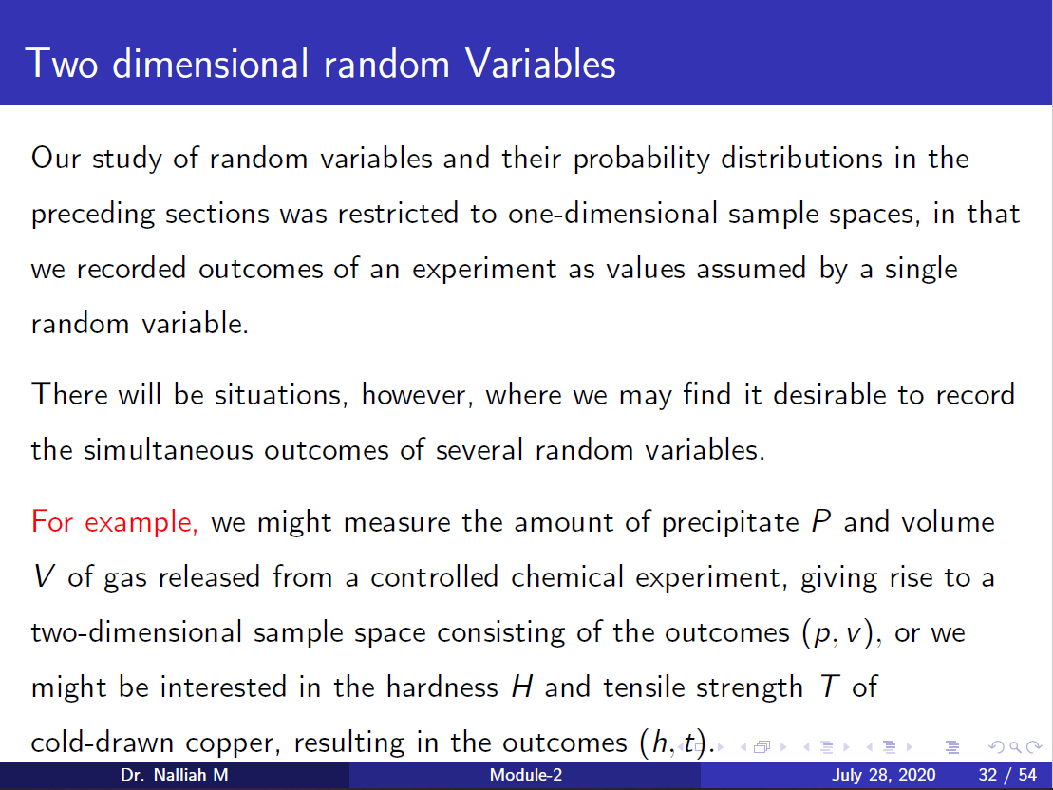

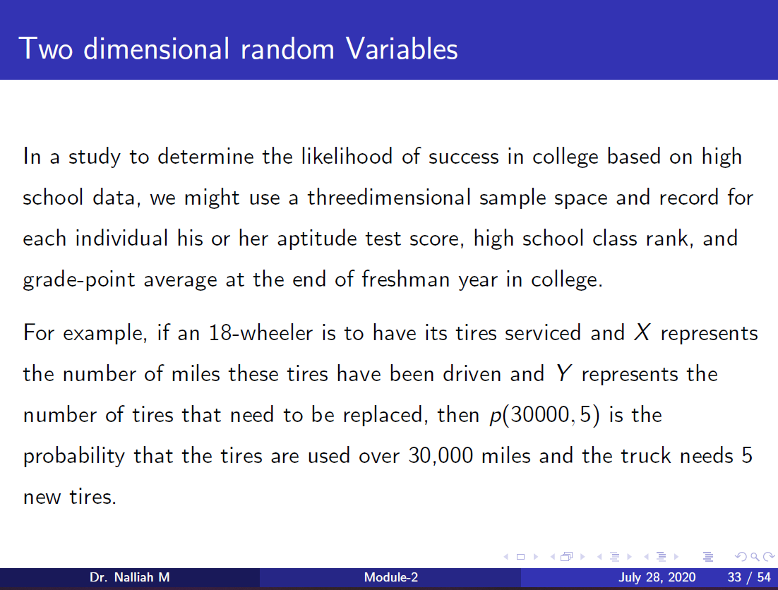

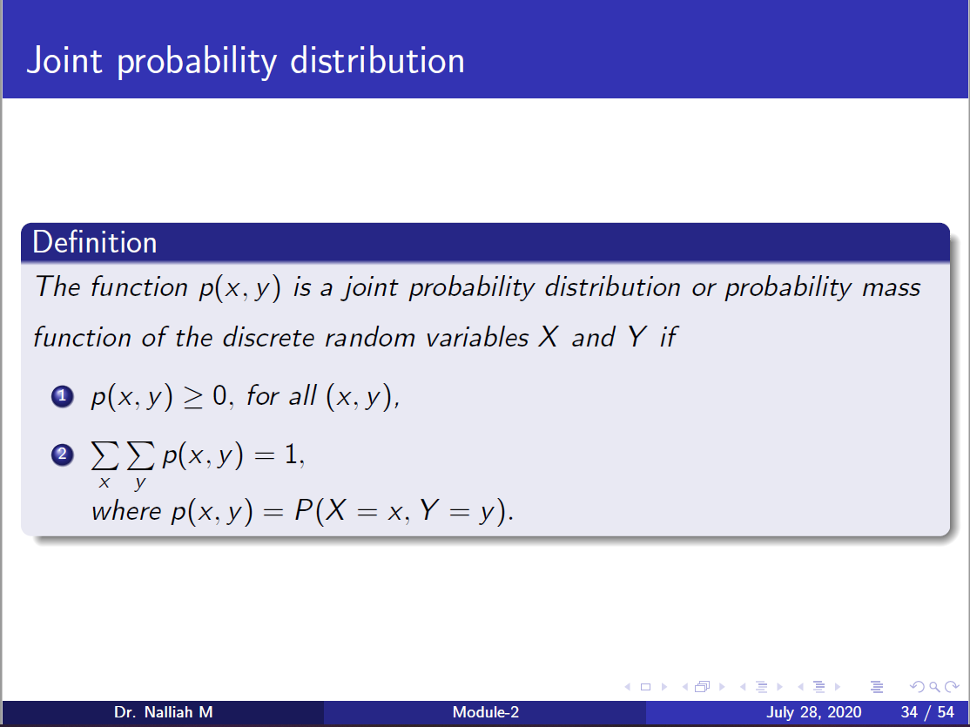

**Variance:**

Variance(x) 🡪 E(x^2) – [ E(x) ]^2  
Variance(x) 🡪 1/n (∑x^2) - x^2   
Variance(x) 🡪 ∑ (xi-x)^2



**Covariance :**

Covariance(x,y) 🡪 E(xy) – [ E(xy) ]^2  
Covariance(x,y) 🡪 1/n (∑ xy) - xy



Karl Pearson correlation coefficient 🡪 Covariance(x,y) / SDx SDy

Spearman Rank Correlation 🡪 1 – ( ∑ di^2 / n(n^2-1) )  
di 🡪 Rank of X - Rank of Y

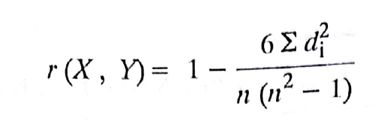

Repeated Rank Correlation🡪 1 – 6 [ ∑ di^2 + 1/12 m1(m1^2-1) + 1/12 m2(m2^2-1) +..+ ] / n(n^2-1)

**Partial and Total correlation**

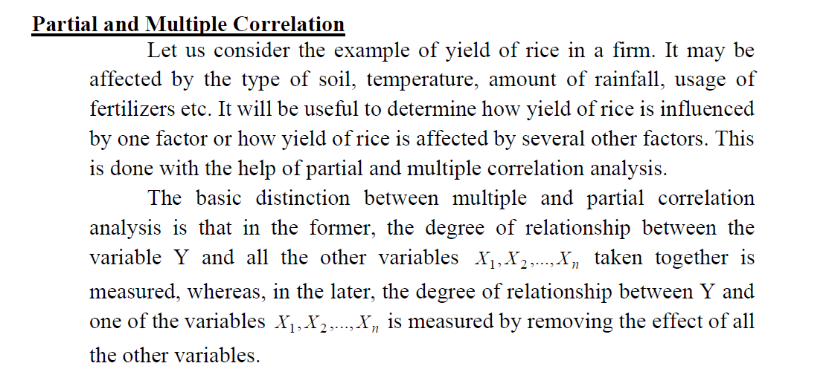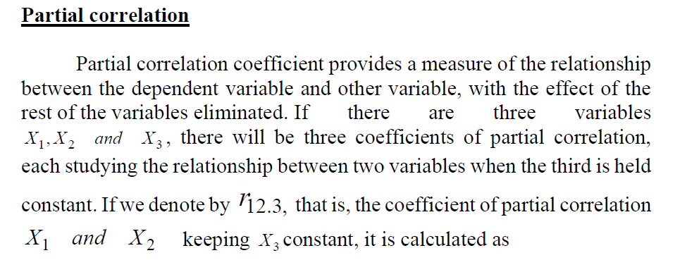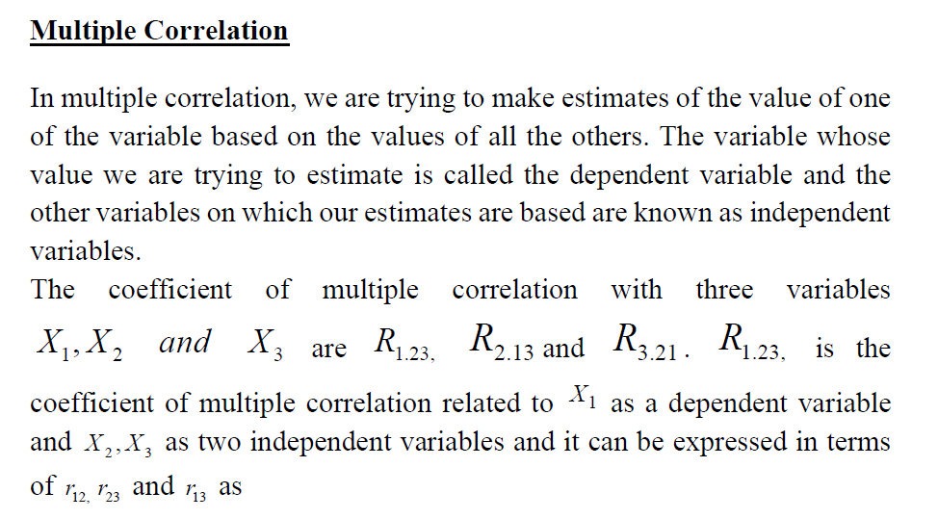

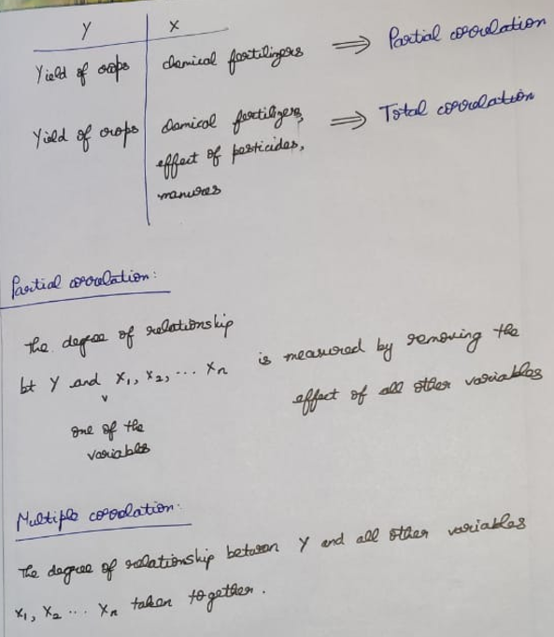

Bt 1 and 2 by keeping 3🡪constant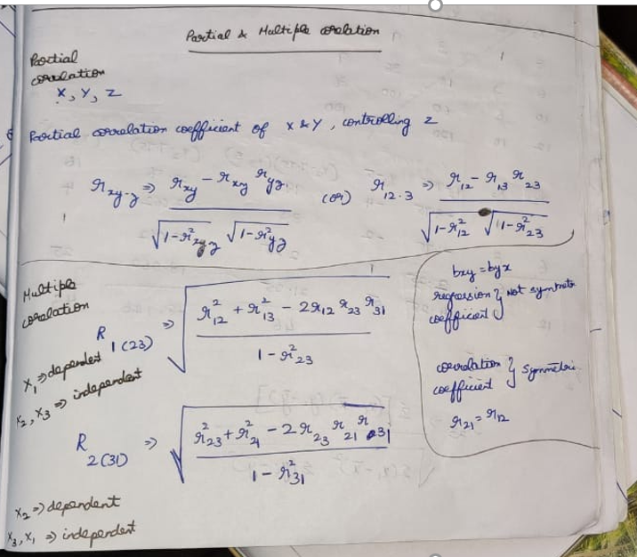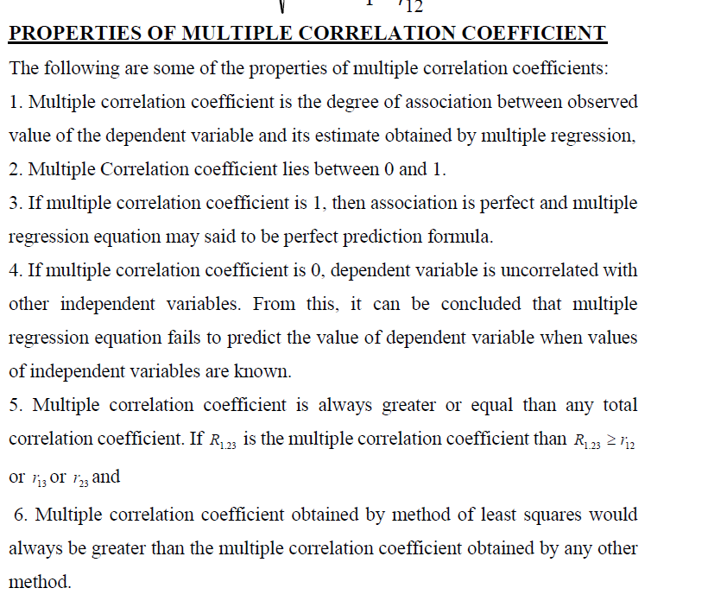

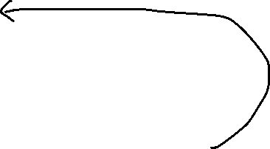

Binomial Distribution

Question : Whatever asking to find out 🡪 success

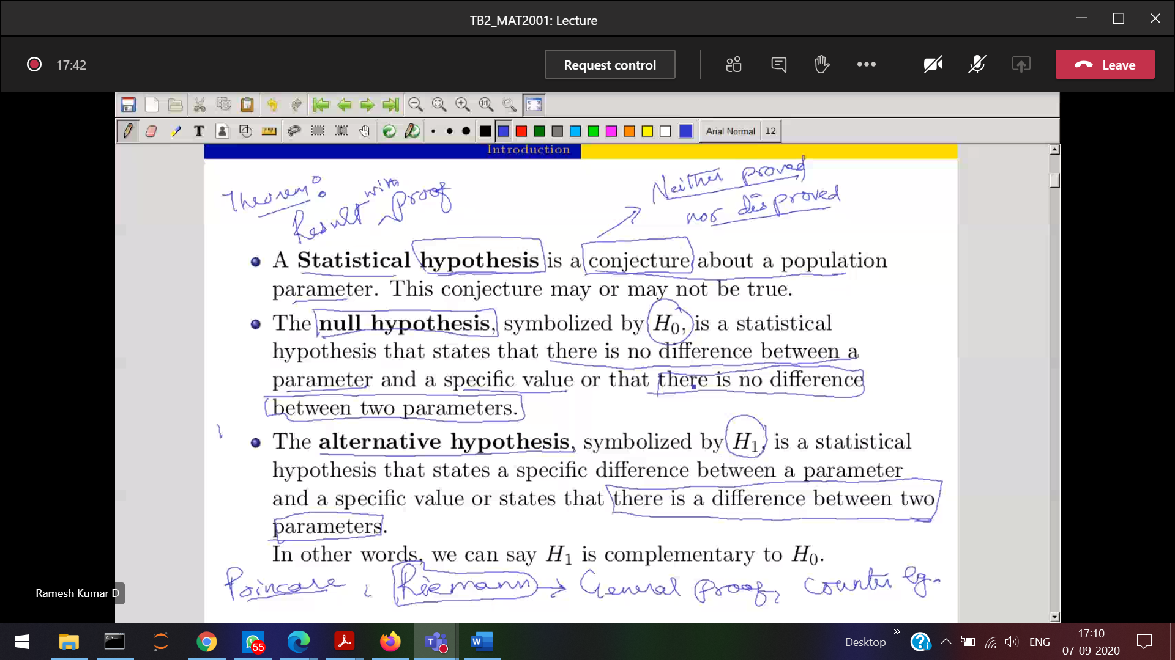

**H1 complement of H0**

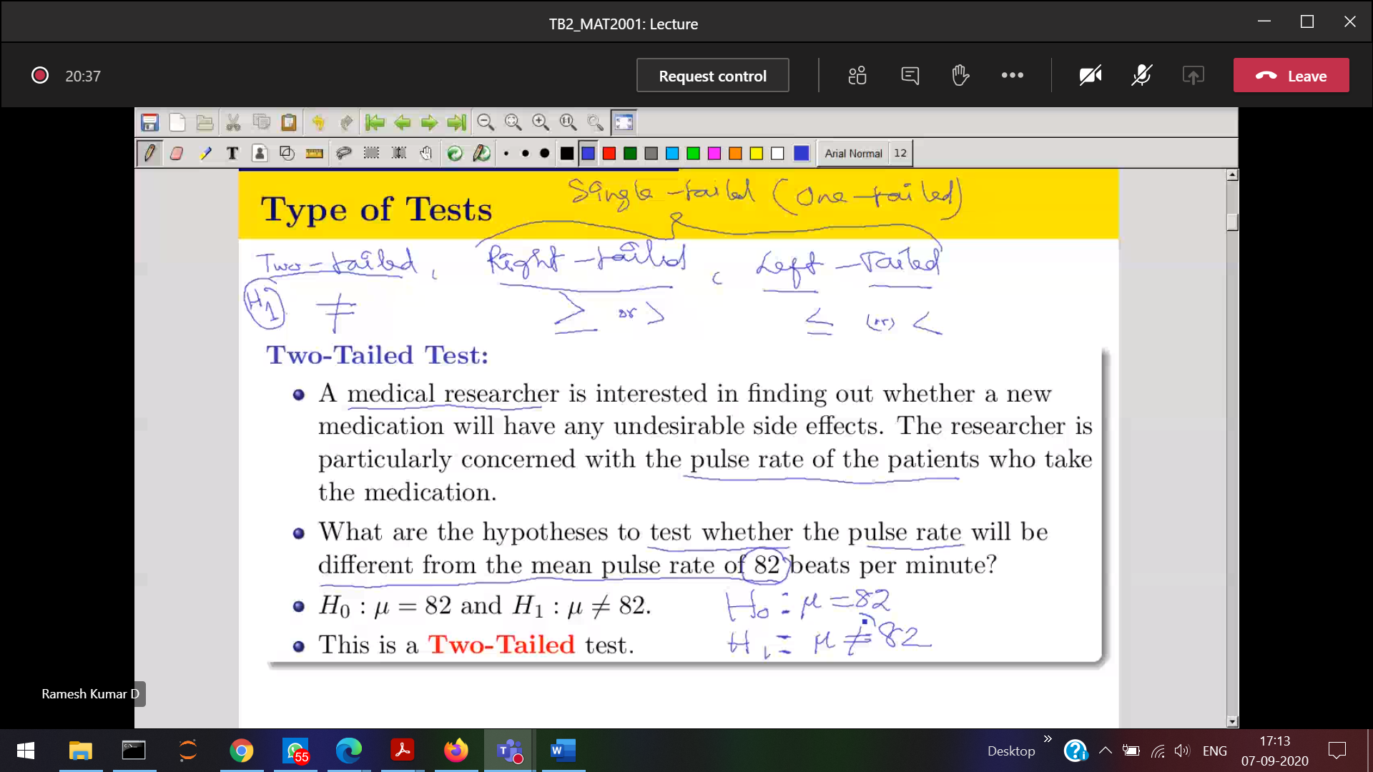

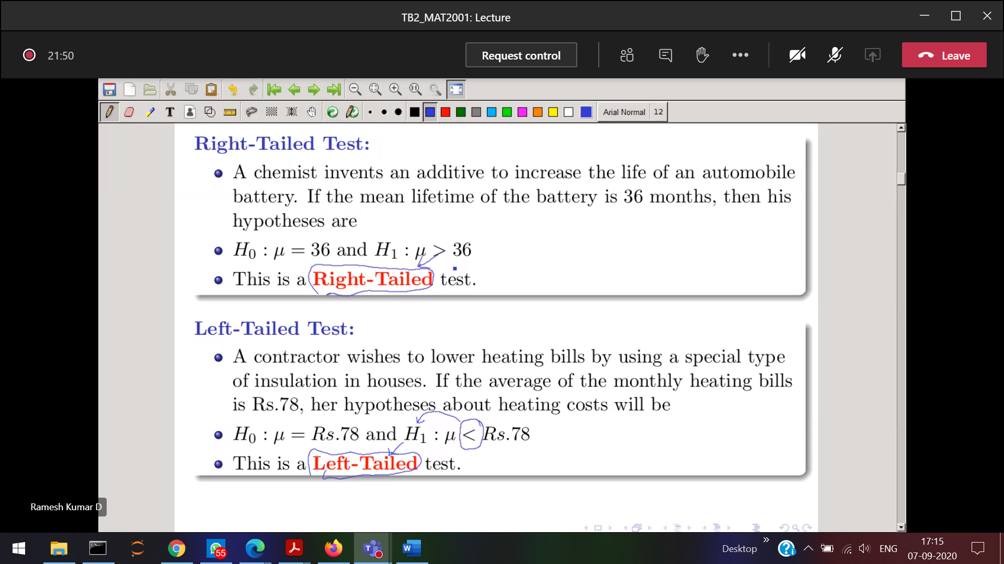

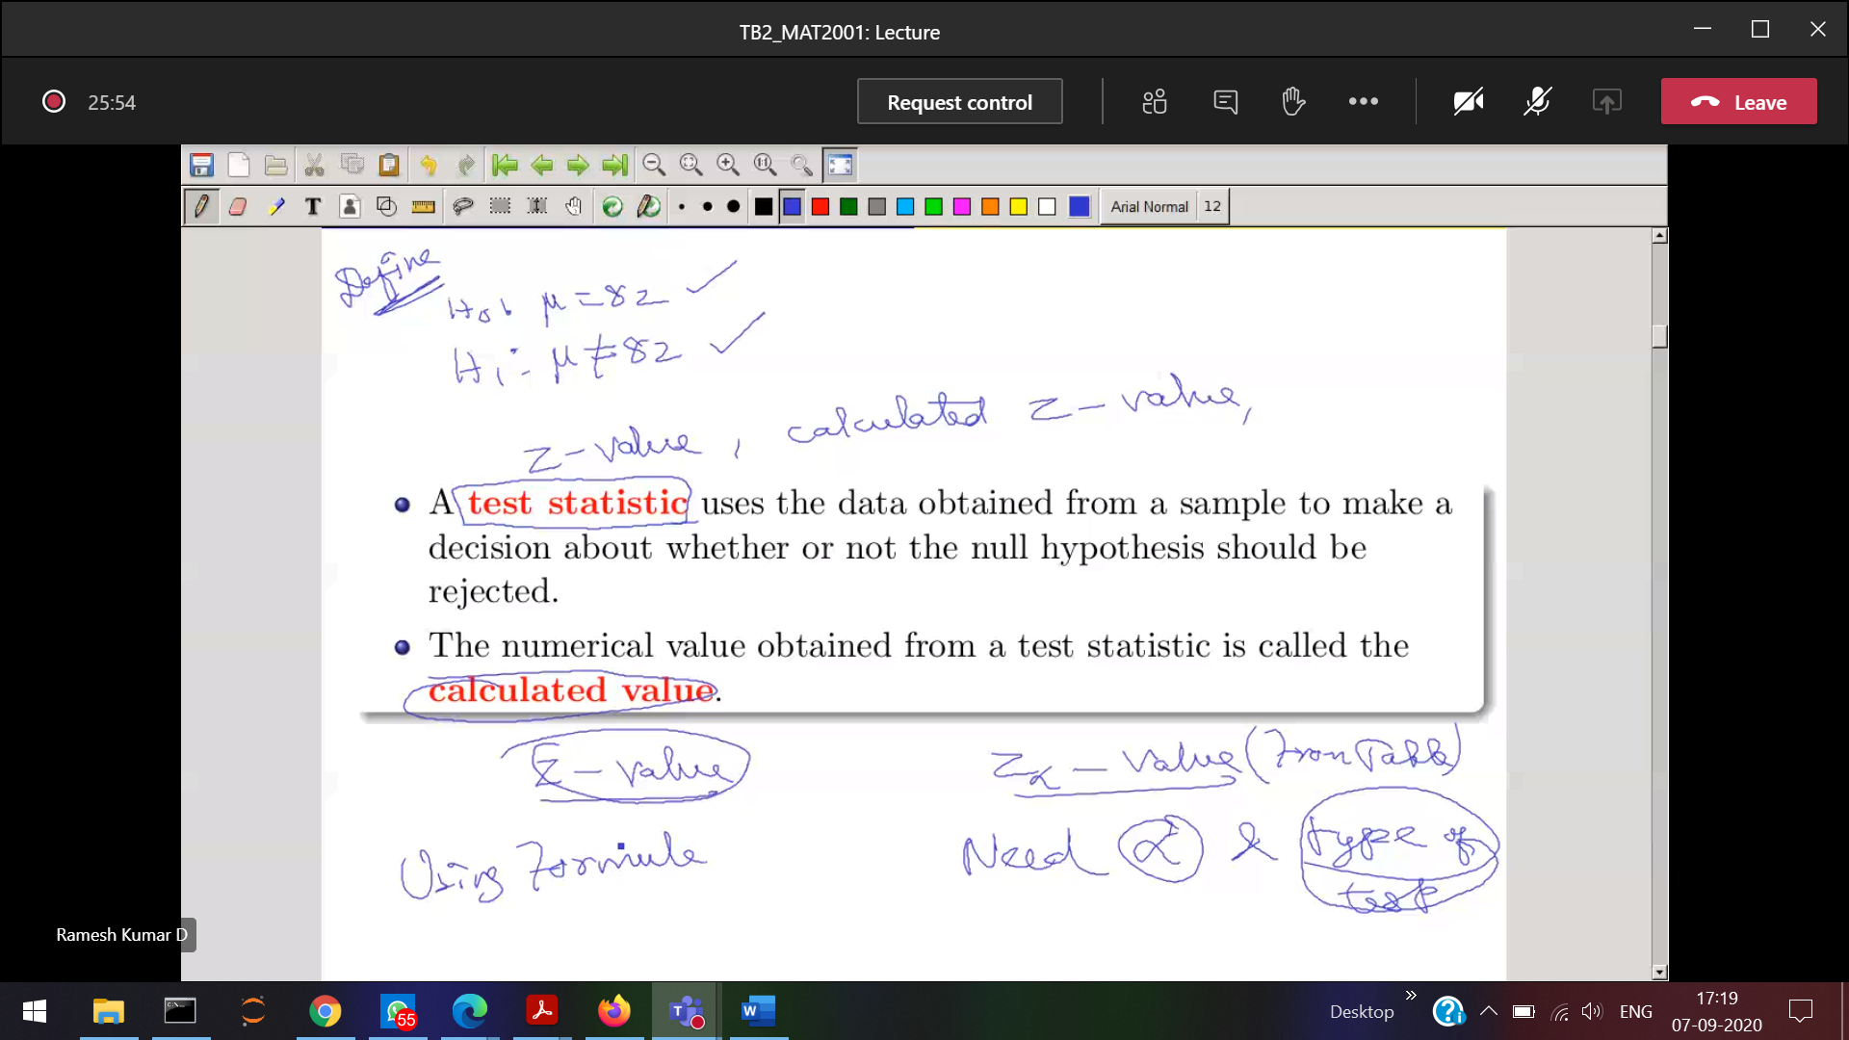

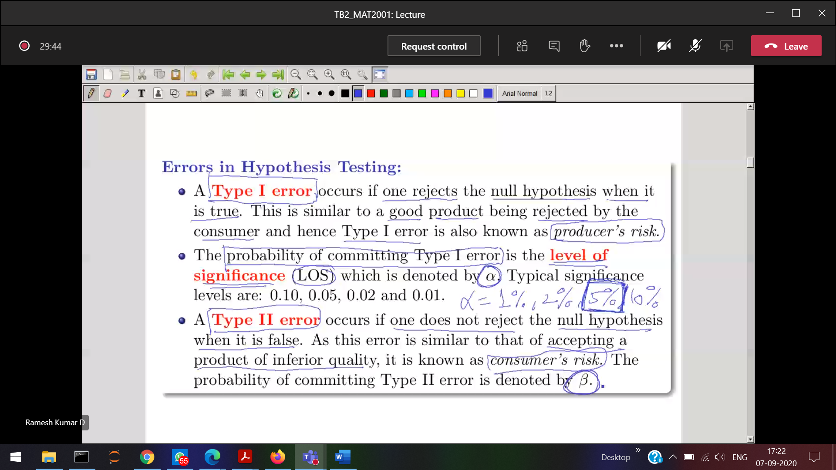

**Type-1 and Type-2 are complement to each-other**

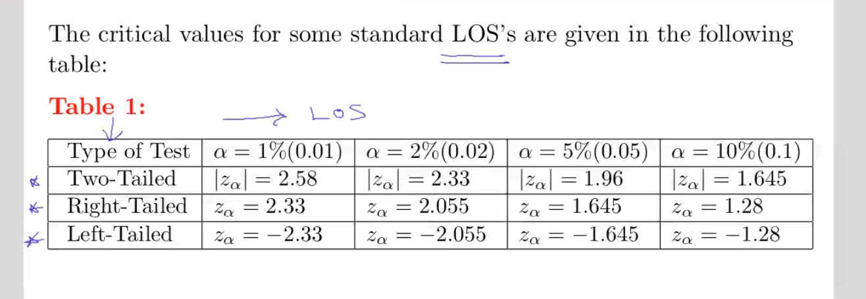

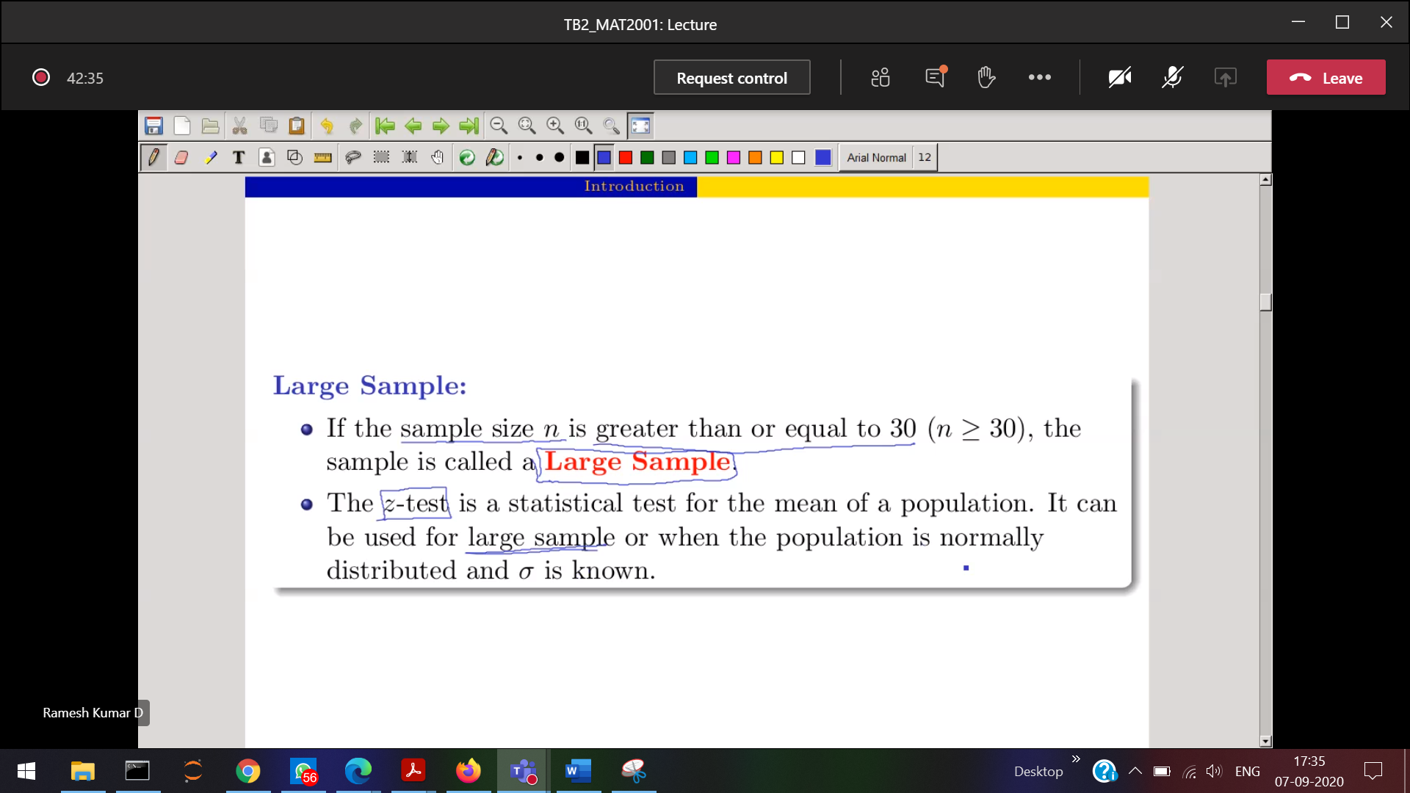

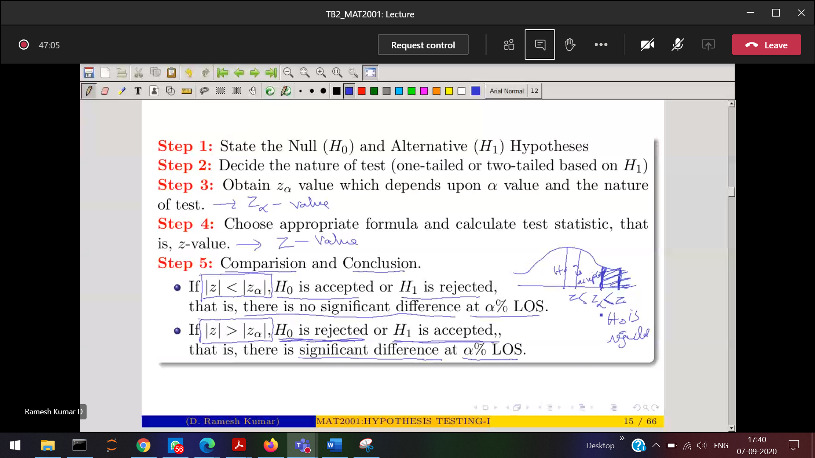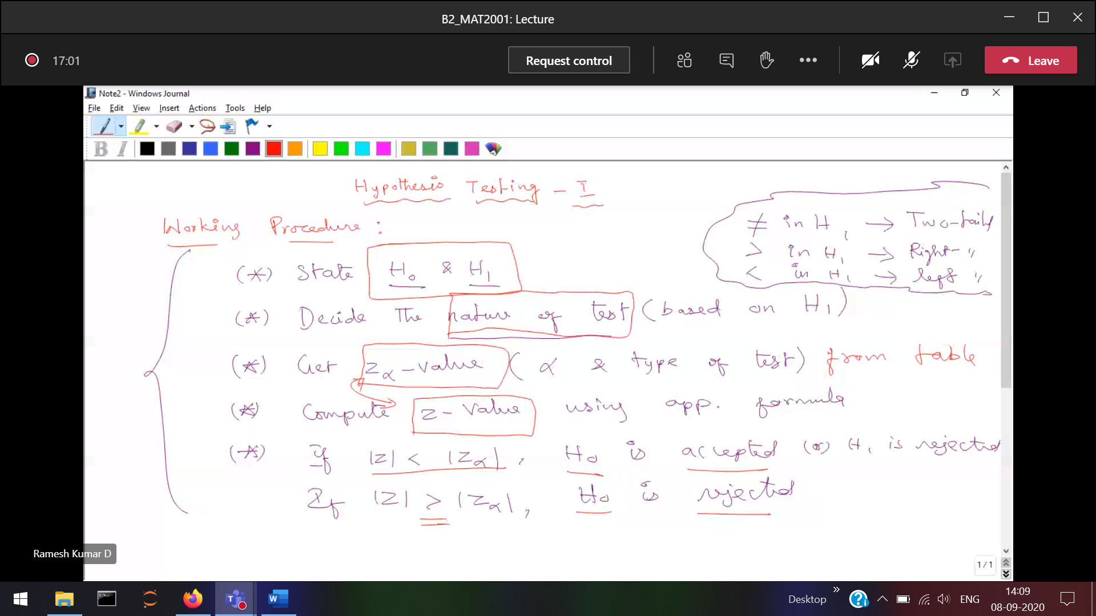

**Z basically denotes area­­­­­­**

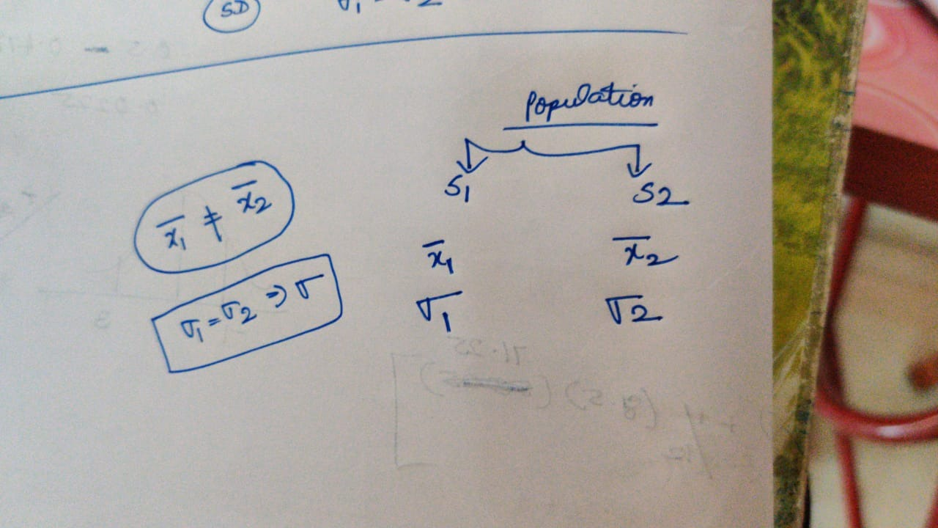

**The SD’s are same, but the means should not be the same,**

**Differentiation**

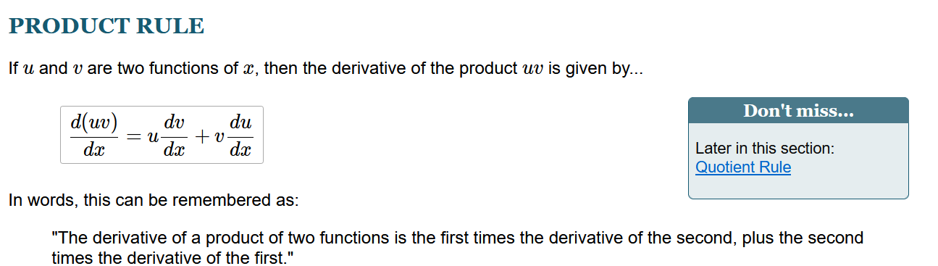

**u*v = uv’+vu’**

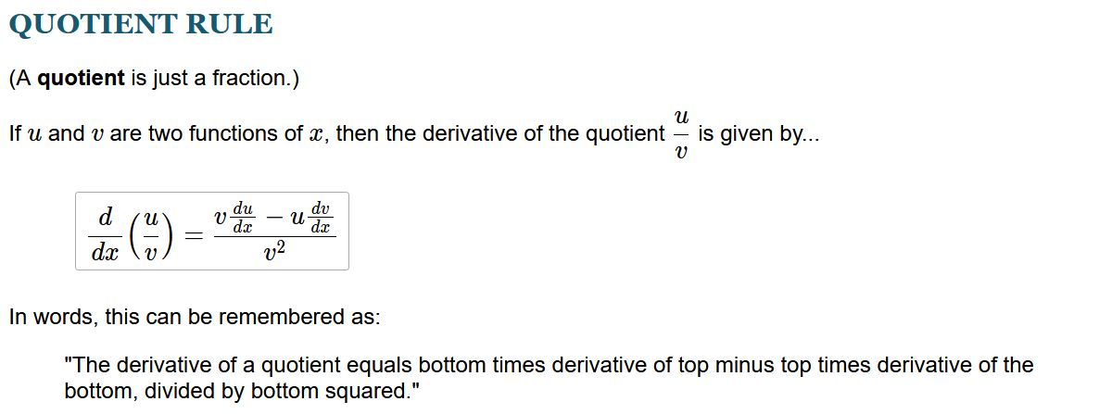

**u/v = (vu’ – uv’) / v^2**

**Binomial formulae**

**n is positive**

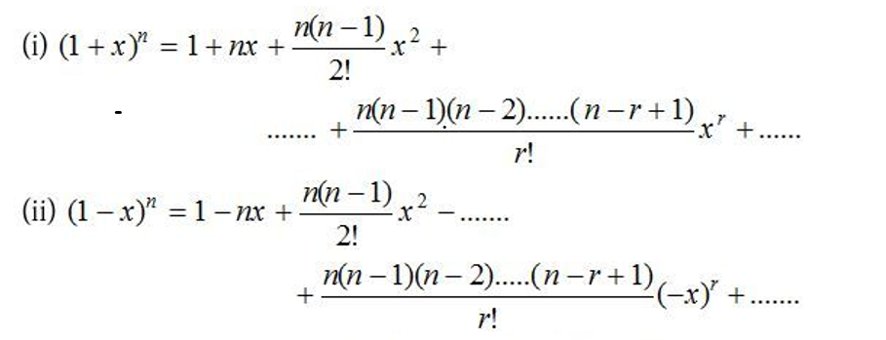

**n is negative**

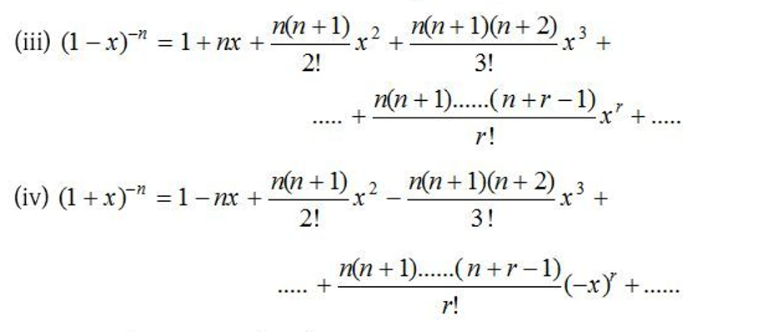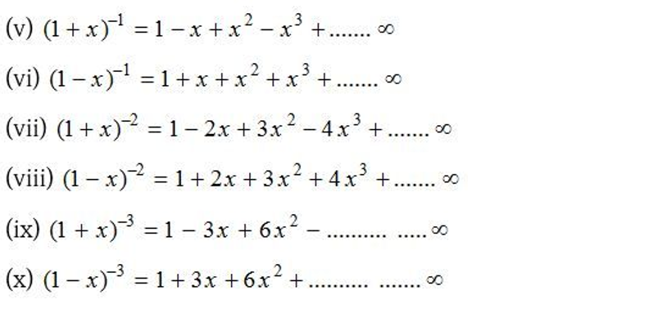

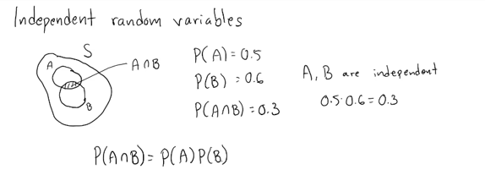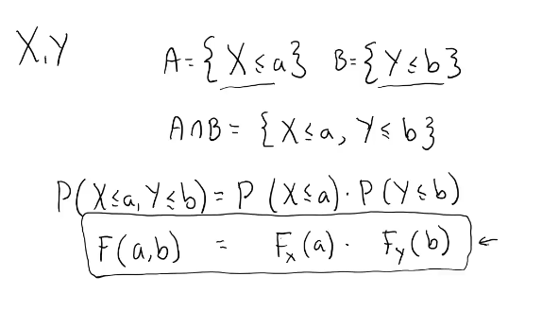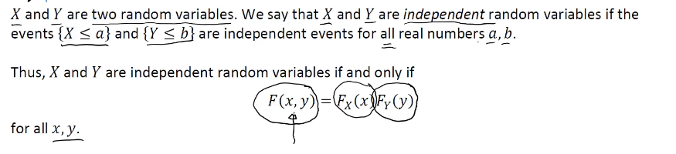

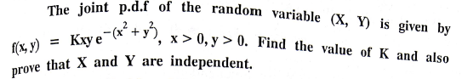



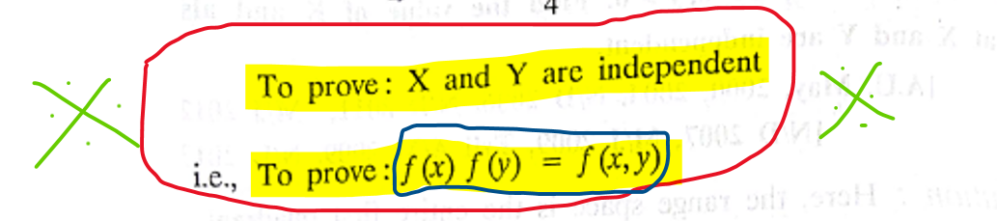**­**

**Conditional probability of Joint probability density function**

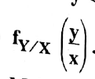 **gives** 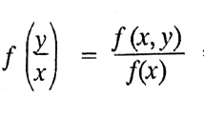

**Joint probability density function(x,y) in the marginal density function(x)**

